Required Python Libraries: matplotlib

For installation help, see https://www.liquidweb.com/kb/install-pip-windows/. If you already have pip installed, find the directory C:\Users\**username here**AppData\Local\Programs\Python\Scripts. Then hold Shift+Right Click and select open command line or open PowerShell. Then type in pip followed by the name of the Python library (eg, pip install matplotlib). If you are working in PyCharm, locate the Scripts folder associated with your given project and do the same installation process.

I. Hardware

The main components of the accelerometer system consists of an ATMEGA328P microprocessor, two accelerometers, and an sd card reader. This is supported by a 5v and 3.3v power supply (with a 9v battery) as well as a 16 MHz ceramic oscillator. To turn the whole system on, connect the white wire from the battery to the unconnected pin on the lower protoboard (between the voltage regulators).

Also included is a pinout sheet for the ATMEGA328P. If there are ever any connection problems or unforseen bugs, have a look at the **accelerometerreading.ino** file to find out which inputs should be receiving what data (you will need some kind of program that can read and write .ino files, I suggest using the one provided by Arduino that can be found on their website). The associated pins can be identified from the pinout sheet included below.

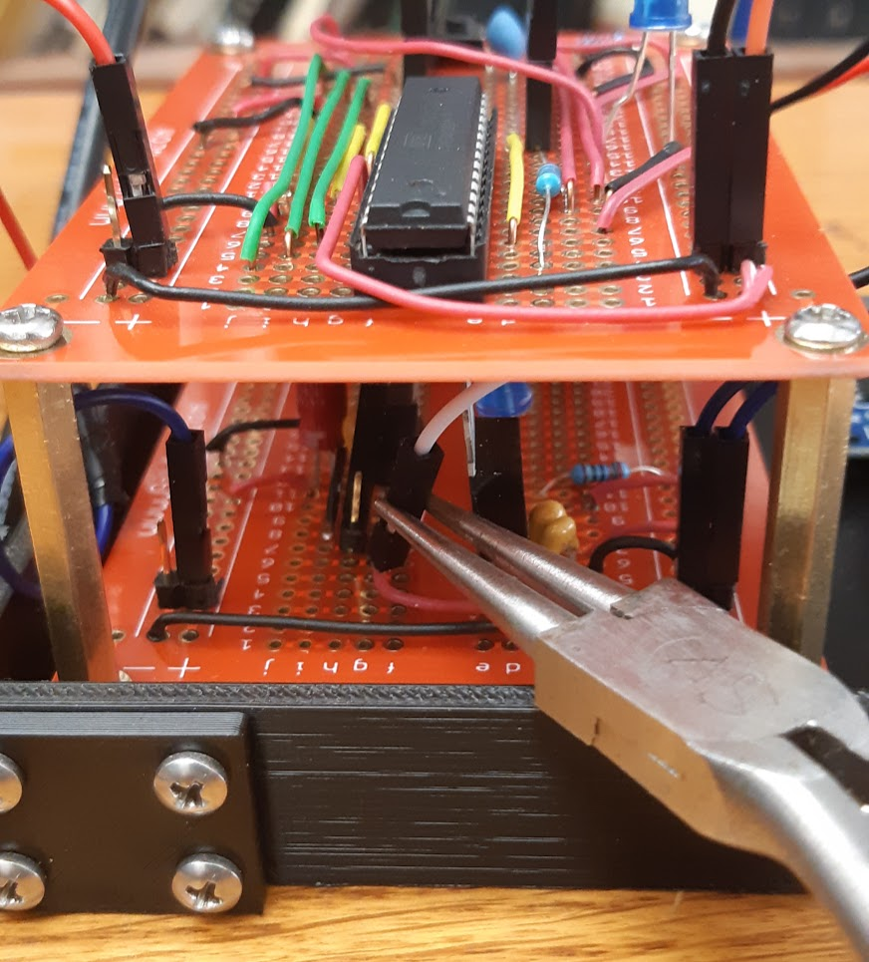

*The aforementioned white wire and unconnected pin*

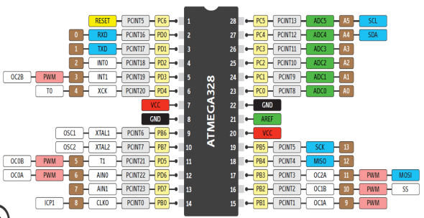

*An ATMEGA328P pinout sheet*

II. Operation

1. SD card preparation

Before inserting the micro SD, check that it contains a file called **TRACK.txt** in its base directory. This file has a single number written in it which serves as a label for subsequent tests and tracks which iteration it is on. The system will not work without this file. If you would like, you can reset this number manually to 1 making the next vibration test have the title **TEST1.txt**. This will overwrite the previous **TEST1.txt** test file however, so make sure to save this externally beforehand.

1. Data recording

After inserting the micro SD into the reader, turn the system on. On the lower protoboard, the blue LED should turn on, indicating that power is being supplied at 3.3v and 5v. Affix the smaller enclosed box to whatever you are monitoring (axis information is written on the box). Now, press the button on the upper protoboard. This begins the test and data should start recording once the second blue LED turns on (there is a small delay to file creation and accessing). Once you are finished, press the button once more and the LED should turn off again. Unplug the white wire and remove the SD card for post processing.

1. Post processing

For post processing, copy the desired test file to the same directory as **plot.py**. Change the **file** variable to the same name as the test file and run the program. This creates and saves three graphs into the current working directory that show the x, y, and z vibrations vs. time.

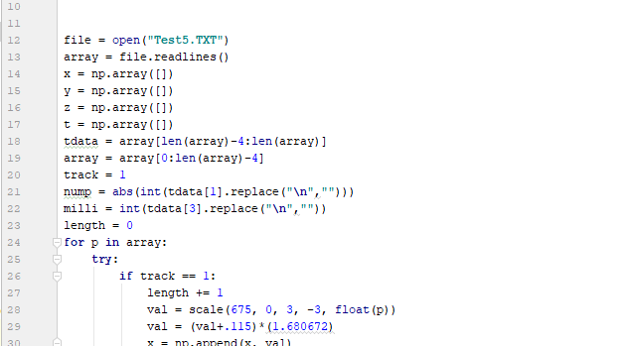

For a fast fourier transform, open the **fft.py** program and apply the same steps as for **plot.py**.